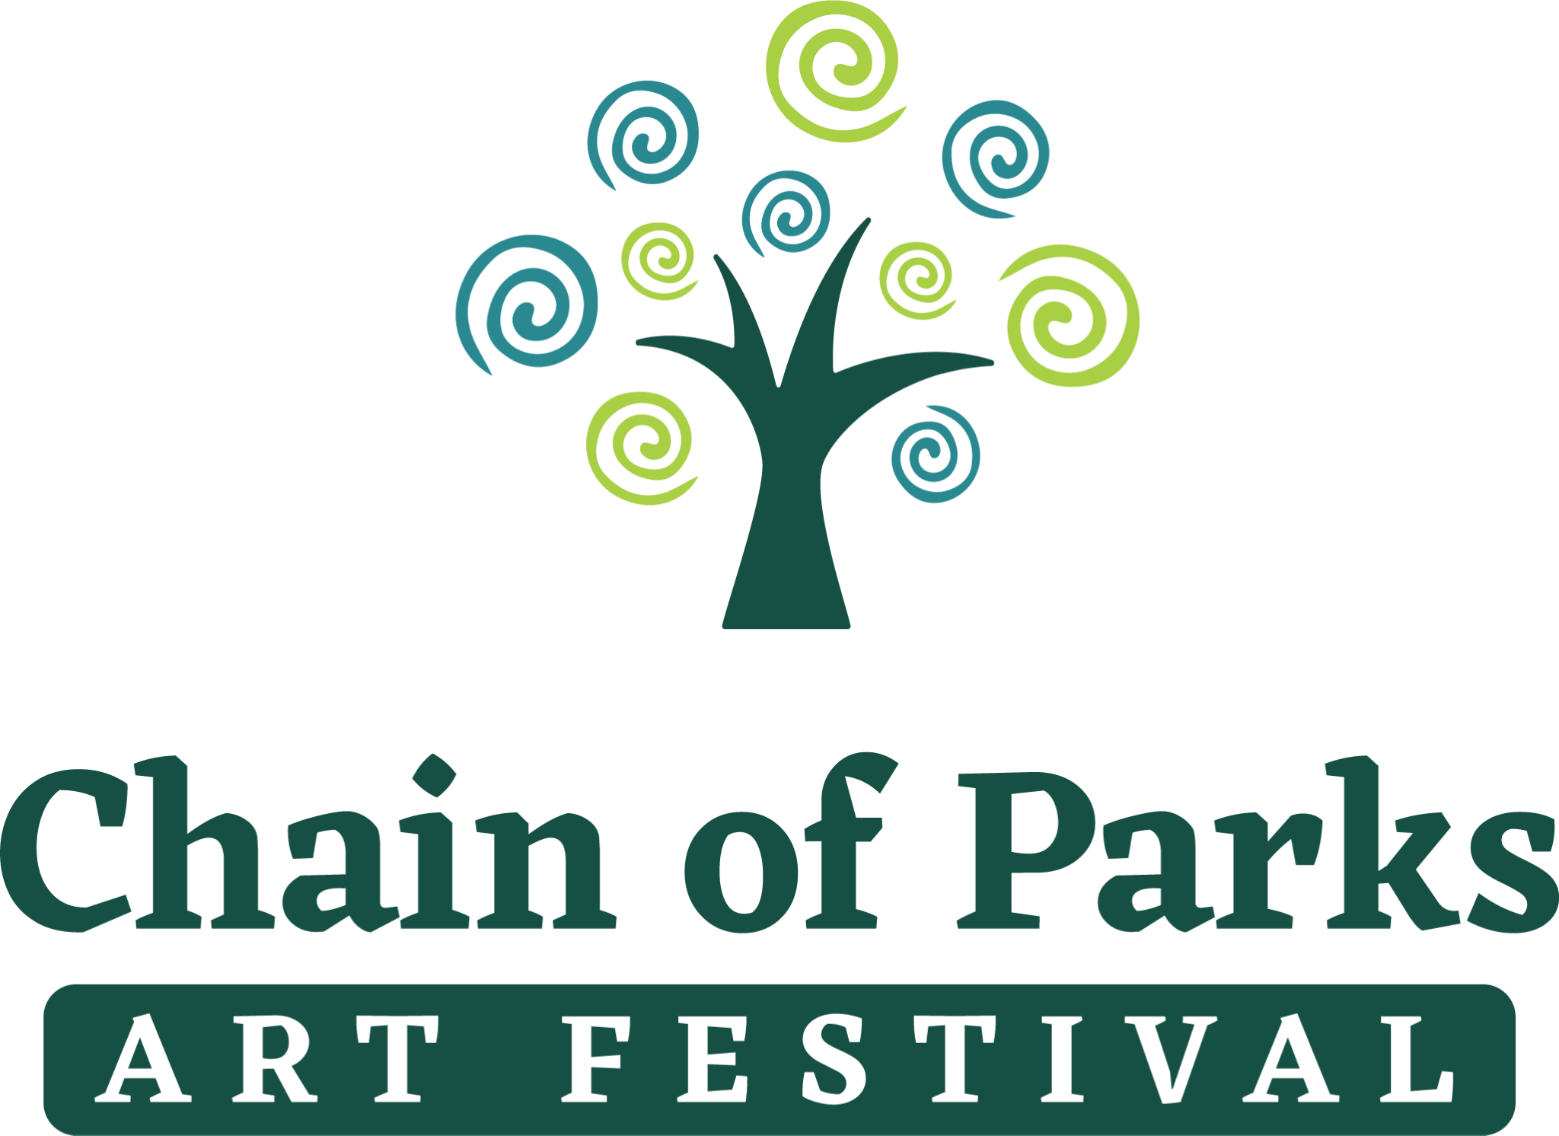

FOR IMMEDIATE RELEASE:
January 17, 2023

Media Contact: Taylore Maxey
(850) 212-5034
Taylore_m@yahoo.com

Kelly Dozier, Festival Chair
(850) 544-6399
kelly@morethanbuildings.com

LeMoyne to Host Soiree Highlighting 2023 Chain of Parks Art Festival
Cover Artist Reveal for North Florida’s Premier Fine Art Festival

TALLAHASSEE, Fla. – In anticipation of LeMoyne’s 23rd Annual Chain of Parks Art Festival this spring, LeMoyne will unveil the Festival’s 2023 cover art and artist during a “Sponsor Appreciation & Announcement Soiree” on Thursday, Jan. 19, at LeMoyne Arts, 125 N. Gadsden Street.

The event will feature live music by Madison Avery, an open bar, and catering by Lagran Saunders and Ben Baldwin. Following the special announcements and cover art reveal at 5:45 p.m., the new exhibit, “Passionate Journey,” featuring artist Eluster Richardson, will debut to the public, 6-7:30 p.m. There will be a gift basket raffle with items from Tallahassee Black-owned businesses, and a performance by the Ayoka Afrikan Troupe on the new front Bye Plaza at 6:30pm.

**While the event is exclusive to special guests and Festival sponsors, local media are invited to participate, with announcements at 5:45 p.m.**

Top-ranked Festival

LeMoyne’s Chain of Parks Art Festival was recently named the No. 1 Florida art festival and the No. 7 art festival nationwide in the category of Fine Art and Design for 2022, according to Sunshine Artist Magazine. Organizers believe the 2023 event will be one of the best yet, set for Saturday and Sunday, April 15-16, at the Bloxham, Lewis and Randolph “Chain of Parks,” located in Downtown Tallahassee. The event as always is free and open to the public.

“The Chain of Parks Art Festival brings some of the nation’s top fine artists to the Capital City as a way to not only expand on the opportunity for regional art collectors, but also introduce fine arts to those who may not have experienced it,” said Festival Chair Kelly Dozier.

At this premier fine art event, visitors can view and purchase unique works of art from 150 carefully selected fine artists while enjoying a weekend filled with interactive children’s art activities, mouth-watering food, live entertainment and local heritage re-enactments.

New in 2023

“Each year, we assess the best way to improve or add elements to the Festival to make it the best experience for attendees and artists,” said Powell Kreis, LeMoyne’s Programming Director and Festival Manager. “We are planning several special additions for 2023 that add to the cultural and nature experiences in our beautiful park setting.”

After a successful inaugural Downtown Pop-up Exhibit of painted rain barrels last year, a 2023 Pop-up Exhibit will feature whimsical Birdhouse Sculptures placed at the Festival’s downtown sponsor locations for the public to enjoy. Up to 10 local and regional artists will create the public artworks, which will be displayed throughout Downtown Tallahassee, March 15 – April 14, and then transferred to the Festival for a Silent Auction.

“We are looking forward to strolling through the display of whimsical, creative birdhouses made using sustainable materials to go along with our greening efforts,” added Kreis.

The Festival will again welcome several 3-D chalk artists to create live during the event. To enhance this experience, a favorite in recent years among guests, the Festival will include a natural oasis where attendees can sit, rest and enjoy viewing the artists while they work on their creations.

Building on the previous years’ success of the Jacques Le Moyne encampment, “The Village” area will be back with even more interactive local heritage booths recognizing the many groups that have contributed to the culture and heritage of our community.

Juried Fine Art Competition

Artisans travel from across the nation to display their original works of fine art for sale, helping to further the importance of fine art in the lives of community members. On Saturday of the Festival, judges will review the artists’ works in each media category and winners will be announced on Sunday, when the winning artists’ award ribbons and flags will be displayed in their booths. Winning artists vie for a total of $10,000 in awards.

Learn More

The Festival continues to have a positive economic impact on our local community. A recent economic impact study showed that Festival attendees who live outside of Leon County had an impact of close to $1.2 million dollars on the local community, meaning increased spending at local businesses resulting from tourism dollars. Last year’s Annual Chain of Parks Art Festival drew 38,500 total attendees.

For more information on the 2023 Chain of Parks Art Festival, visit the website www.ChainofParks.com. Receive the latest Festival social media updates on Facebook, Instagram and Twitter.
# # #

