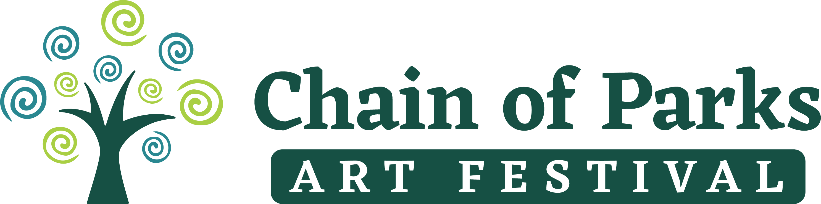

CoP 2021 Safety Protocols:
As the world copes with the challenges of COVID-19, the Chain of Parks Art Festival (CoP) will be implementing new safety practices and requirements to keep our artists and community SAFE! The festival will follow current scientific and governmental guidelines for safety.
These guidelines and safety tips will be visible throughout the festival and will be publicized on our website, marketing materials, social media pages, and signage at the festival to ensure awareness.
In previous years, the CoP allowed for casual wandering in and out of the festival area. For 2021, the festival will create new entrance and exit locations made up of decorative barricades with festival volunteers at each location. The new festival entrances will be used to control crowd sizes, provide handwashing stations, hand sanitizer stations, and confirm proper face covering compliance.
CoP plans to manage crowd sizes/ expectations by changing to a FREE ticketed event (via Eventbrite), allowing visitors to select the day and time they would like to attend so that we can balance the flow of attendees and not have the usual surge on Saturday at lunchtime. CoP will have a color-coded wristband system to help guests understand how long they can stay in the parks.
The festival is planning to have 4 of these entrances (Gate A, B, C, or D) and is going to recruit art clubs, school students and local artists to make decorations that can be attached to the metal barricades to beatify the area. At these entry points, volunteers will check tickets and provide wrist bands noting their shift to be in the festival. If the crowd size reaches capacity, entrances will be temporarily closed while exits remain open until it is safe to resume entrance.
Estimated crowds from the 2019 festival were 40,000 visitors. The 2021 festival will reduced accepted attendance to 6,000 visitors total, broken into 3 shifts per day.
- This capacity number will include artists, vendors, volunteers, and VIP members pending any updates from government officials.
- Arrival times and gate location will be clearly stated on each ticket.
- Visitors may select tickets for multiple shifts, but they will have to go back to their designated entrance to be readmitted.
- Wrist bands will be color-coded by shift. Volunteers will announce a 15, 10, and 5-minute warning when a shift is almost over. Announcements will be made at the main stage PA system and volunteers with color-coded flags will walk around alerting visitors as well.
VIP members will be able to stay all day, but they must make a reservation to enter the VIP Tent. Meals will be served by a small staff of volunteers/ the caterers instead of the usual buffet style accommodations.
The festival will provide free masks at the entrances to those who do not have one and will require face coverings while in the parks. This will be communicated through marketing, social media, volunteers, and step-in signs around the festival. CoP will also encourage sponsors to donate masks with their branding and logos as an addition marketing perk.
Once visitors enter the festival, they will observe directional foot-traffic patterns and 6ft spacing guidelines, predominately illustrated with chalk ground markings, signs and potentially in our festival map. Passing lanes are also under consideration. A standing box will be marked outside of each artist tent so that visitors wait until it’s their turn to go inside the artist booth.
CoP has adjusted the festival layout and map to provide more space between tents, foot-traffic pathways and food truck lines. To achieve this the CoP has reduced accepted applications (from the normal 170 to 125 for this year), expand placement on N. Calhoun and N. Gadsden St, and reduce the food vendors, community partners and children’s section called The Village.
Instead of the traditional Village, the festival is going to rework this space into a decorative picnic area. This will help avoid direct contact and clusters of people in any one place while eating.
CoP also is planning to replace the traditional BeTheArt installations (that require visitors to stick their face through a hole of a classic painting) to a printed “selfie station” they can stand in front of. Depending on cost, the selfie stations will be printed with artwork from local artists, almost acting like a mural where the visitors standing position will complement the art piece and create a social-media worthy photo.
The festival has already reserved 20 handwashing stations which will be strategically placed throughout the festival. Larger portalets have been requested. Proof Brewing Co. has also agreed to donate hand sanitizer for all artists and volunteers. A crew of volunteers will be stationed near the eating areas and bathrooms for frequent sanitation of all surfaces.
Food/ rest stations will be placed throughout the park instead of being concentrated in the traditional food court area.
All food and beverage vendors (including food and beverage inside the VIP areas) will comply with any applicable CDC guidelines relating to food concessions and restaurants.

The festival will promote and encourage visitors to use touch-free payment methods with artists and food vendors. CoP will also make the visitor survey and festival program available online.
Currently, the CoP is looking into virtual and live-stream festival options for those who cannot physically attend. Social media live-streams will be heavily used over the weekend.
No matter what, the Chain of Parks Art Festival is committed to having a FUN and SAFE experience for the community. If the festival needs to be canceled, the CoP will need to announce any cancelations by March 2021. However, the CoP has several NEW INITIATIVES in place that will expand the timeline of the festival and can be achieved even if the traditional festival at the park is forced to cancel. The appeal for this longer festival is that people can come and visit Tallahassee and stay for multiple days, spread out their visits to the various venues and engage with the community and the arts in a unique way. These new initiatives may need additional support as we diversify and extend the offerings of the Chain of Parks Art Festival.

New for 2021:
- April 9th-18th, 2021: “Zerbe Zelebration”
  - The festival is extending the usual timeline to include this city-wide exhibit & interactive virtual activities to celebrate renowned artist, Karl Zerbe. This will kick off a week before the festival on April 9th and go until the end of April.
  - This city-wide exhibit project is in partnership with LeMoyne Arts, COCA, FSU’s MOFA, FAMU, TCC, Proof Brewing, The Tallahassee Chamber of Commerce and private collectors. Collections of Karl Zerbe’s work (and those inspired by him) will be accessible to the public in multiple locations and online.
- April 15th, 2021: Opening Nights Presenting Artist
  - Will be in person or online. Artist is already confirmed.
- April 15th - 16th, 2021: Printmaking Workshops with Jim Sherraden
  - This will be a combination of small in-person outdoor workshops at LeMoyne Arts combine with a virtual option.
- April 17-18th, 2021:
  - Artists in the park will be a limited, FREE (ticketed) event with the safety protocols mentioned above.
  - The Saturday Evening Groove will not occur, but there will be live entertainment during the day.
  - Possible mask contest.
  - Professional chalk artists throughout the park.

