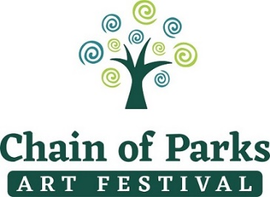
Produced by LeMoyne Arts
Presented by Mad Dog Construction

Media Contacts: EMBARGOED FOR:
Taylore Maxey | (850) 212-5034 | taylore_m@yahoo.com Thursday, January 21, 2021
Powell Kreis | (850) 445-6367 | Powell@lemoyne.org for media to release story
Kelly Dozier | (850) 544-6399 | kelly@morethanbuildings.com

LeMoyne Arts to Unveil 2021 Chain of Parks Art Festival
Cover Art and Artist at Soiree
~Donor Appreciation and 2021 Festival Reveal~

TALLAHASSEE, Fla. – The Chain of Parks Art Festival will unveil the 2021 Festival Cover Artist during the annual soiree on Thursday, January 21, 2021. Hosted by LeMoyne Arts, the soiree will also be a time to thank donors and loyal Festival supporters as we prepare for the newly expanded weeks-long celebration in April celebrating the arts. The reveal is one of the most anticipated aspects of the Festival as it showcases the new cover art and artist.

The evening of art and music is set to take place on Thursday, January 21, from 5:30 pm to 7:00 p.m., at LeMoyne Arts, 125 N. Gadsden St. Festival organizers will introduce inspiring cover art by Jim Sherraden, titled “Kaleidoscope.” The unveiling itself is set to take place at 6 p.m. and is open to the press. Artist Jim Sherraden will be present at the soiree to personally sign festival posters for attending guests.

“We are elated to have the opportunity to plan this festival for the 21st year as well as the exciting expanded new experiences being presented this year!” said Kelly Dozier, Festival Chair. “We are keeping the safety of the community as our top priority as we expand the Festival that we believe supporters and the community will appreciate.”

Other exciting news for the 2021 Festival includes mural artist Michael Rosato as presenting artist in collaboration with Florida State University’s Opening Nights on Thursday, April 15, print making workshops with visiting artist, Jim Sherraden in the gardens at LeMoyne Arts Thursday and Friday, April 15 & 16, and Zerbe Zelebration, a tribute to Karl Zerbe, a world renowned expressionist artist who taught at FSU and had a significant impact on the visual arts in our community. The Zerbe Zelebration, held April 9-18, 2021 is a city-wide collaboration of exhibitions, roundtables, custom Proof beer and social media interactive experiences.
“We all know 2020 has been a tough year, that’s why we think it’s so important to find innovative ways for people to have fun and safe experiences in our community” said Powell Kreis, Festival Manager. “Everyone is anxious for events that make use feel connected while still being responsible; we’re working hard to make that possible for 2021 with the help from our supporters.”

Jim Sherraden, Festival Cover Artist
Jim Sherraden, a native of Kansas, has been a resident of Nashville, Tennessee since 1977. There he completed his university studies, which included a strong education in printmaking. From this foundation, he managed Hatch Show Print beginning in 1984 until 2013, overseeing its transition from a cultural survivor to a widely recognized graphic design icon and destination for letterpress enthusiasts.
Through Hatch, his clients included Emmylou Harris, B.B. King, Neil Young, Bruce Springsteen, Fossil Watch Company, Entertainment Weekly, the city of Nashville, and numerous others. In 1992, he began creating individual pieces of art called monoprints. These artworks are based on the Hatch archive and are collected by individuals and institutions worldwide, including the Ayers collection of Tennessee artists for First Bank in Nashville. Sherraden has travelled extensively, both nationally and internationally, conducting workshops and speaking.
In 2005, Sherraden returned to carving his own woodcuts, continuing the work that first led him to Hatch Show Print over 30 years earlier. Six years later he began creating wooden quilts and then paper quilts the subsequent year. For these works of art, the artist readily cuts up his own printed pieces, mixing and matching them on single and multi-dimensional surfaces. His quilts have recently been shown in 2016 at Yard Dog Gallery in Austin, Texas, Middle Tennessee State University’s Todd Art Gallery, and the AD 20/21 Boston Print Fair, as well as the 2017 exhibitions HATCH-ed at the historic Belcourt Theatre in Nashville and From Brayer to Brush at the Southern Studies Conference at Auburn University Montgomery.
Jim Sherraden is represented by the Haley Gallery in Nashville, which also exhibits his monoprint work created during his tenure as Master Printer at Hatch Show Print from 2013 to 2017. He is currently the shops archivist for its parent company, the Country Music Hall of Fame, Inc., in Nashville Tennessee. Additionally, Sherraden is on the Artists Advisory Board at the Hamilton Wood Type Museum in Two Rivers, Wisconsin, where he currently serves as their visiting artist.

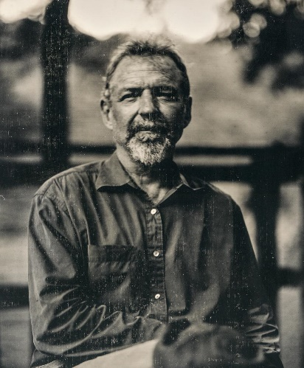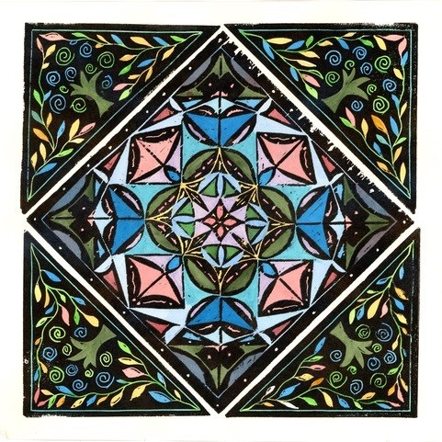
2021 Cover Artist Jim Sherraden and his cover art “Kaleidoscope”

The 21st Annual Chain of Parks Art Festival will be held on Saturday and Sunday, April
17-18, 2021, at the Bloxham, Lewis and Randolph “Chain of Parks,” located in Downtown Tallahassee. The festival is produced by LeMoyne Arts and Presented by Mad Dog Construction. For more information about the Chain of Parks Art Festival, visit www.chainofparks.com or email chainofparks@lemoyne.org.
###

