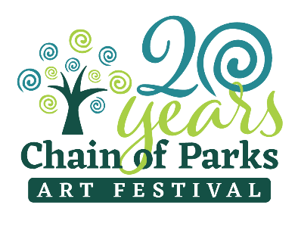
Produced by LeMoyne Arts
Presented by Mad Dog Construction

FOR IMMEDIATE RELEASE:
January 16, 2020
Media Contacts: Kelly Dozier (850) 544-6399 kelly@morethanbuildings.com
Taylore Maxey | (850) 212-5034 | taylore_m@yahoo.com

LeMoyne to Unveil 2020 Chain of Parks Art Festival
Cover Art and Artist at Soiree
~Donor Appreciation and 2020 Reveal Soiree~

TALLAHASSEE, Fla. – LeMoyne’s Chain of Parks Art Festival will host a Donor Appreciation and 2020 Reveal Soiree, Thursday, Jan. 16, thanking its loyal Festival supporters as it prepares for the week in April celebrating the arts, and will highlight this year’s cover art and artist. The reveal is one of the most anticipated aspects of the Festival, held annually in Tallahassee.

The evening of art and music is set to take place Thursday, Jan. 16, 5:30 to 7:00 p.m., at LeMoyne Arts, 125 N. Gadsden St. Festival organizers will introduce inspiring cover art by Kelly Rysavy, titled “Under the Oaks.”

“We are thrilled to be planning our 20th festival and to reveal the 2020 poster art piece as well as the exciting new experiences being introduced to the festival this year!” said Kelly Dozier, Festival Chair. “We have exciting news to share as we thank our Festival supporters and community for helping the Festival be recognized in the top 5 Fine Art Festivals in the nation for a third year in a row!”

Other exciting news includes third year of Top 5 ranking, Top 100 for 5th year with Sunshine Artist Magazine, being named a Legacy Event by Visit Tallahassee, a new festival passport program, presenting artist Michael Rosato to speak at Opening Nights’ Chain of Parks Art Festival shared event and the introduction of four national 3-Dimensional chalk street artists that will create their pieces live at the festival.
The unveiling itself is set to take place at 6 p.m., and is open to the press.

The Festival will also announce the Saturday Evening Groove performance scheduled for April 18th at 5:30pm on the Main Stage. This year visitors to the festival will enjoy the energetic musical performances of Tallahassee Nights Live! This performance is free and open to the public!

Kelly Rysavy, ARTIST

Kelly currently lives in Tallahassee and St. George Island, Florida. Being primarily a self-taught artist, her oil paintings range from landscapes, figurative studies, and still-life’s as well as an occasional abstract. Her subjects, media and techniques vary vastly due to the fact she wants to experience and try everything.

Over the last three years she has been traveling around Florida doing several art shows. She states,” I am so excited about the opportunity to meet with collectors and network with other artists. There are so many talented artists out there and I learn so much from them while on the road.”

Making the pursuit of art a full-time commitment was the best and most fulfilling thing she ever did.

While she enjoys the quiet solitude of her studio, she delights in painting on location and is doing more plein-air than ever. She states, “Painting from life creates an intimacy with the subject that I just can’t get from photographs, and it heightens my sense of spontaneity. That energy is translated to the canvas in and out of the studio. I don’t want to be branded as an artist that only paints one thing. How will I grow and learn from doing that. Also, what interests me most is the relationship between the color harmony, patterns and shapes. I like to view life at a glance and try to capture it on canvas. I want my art to engage viewers, like those who pass by while painting on location and have them stop and experience the work with me.”

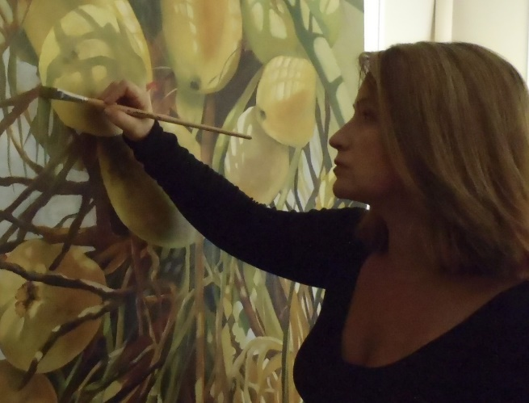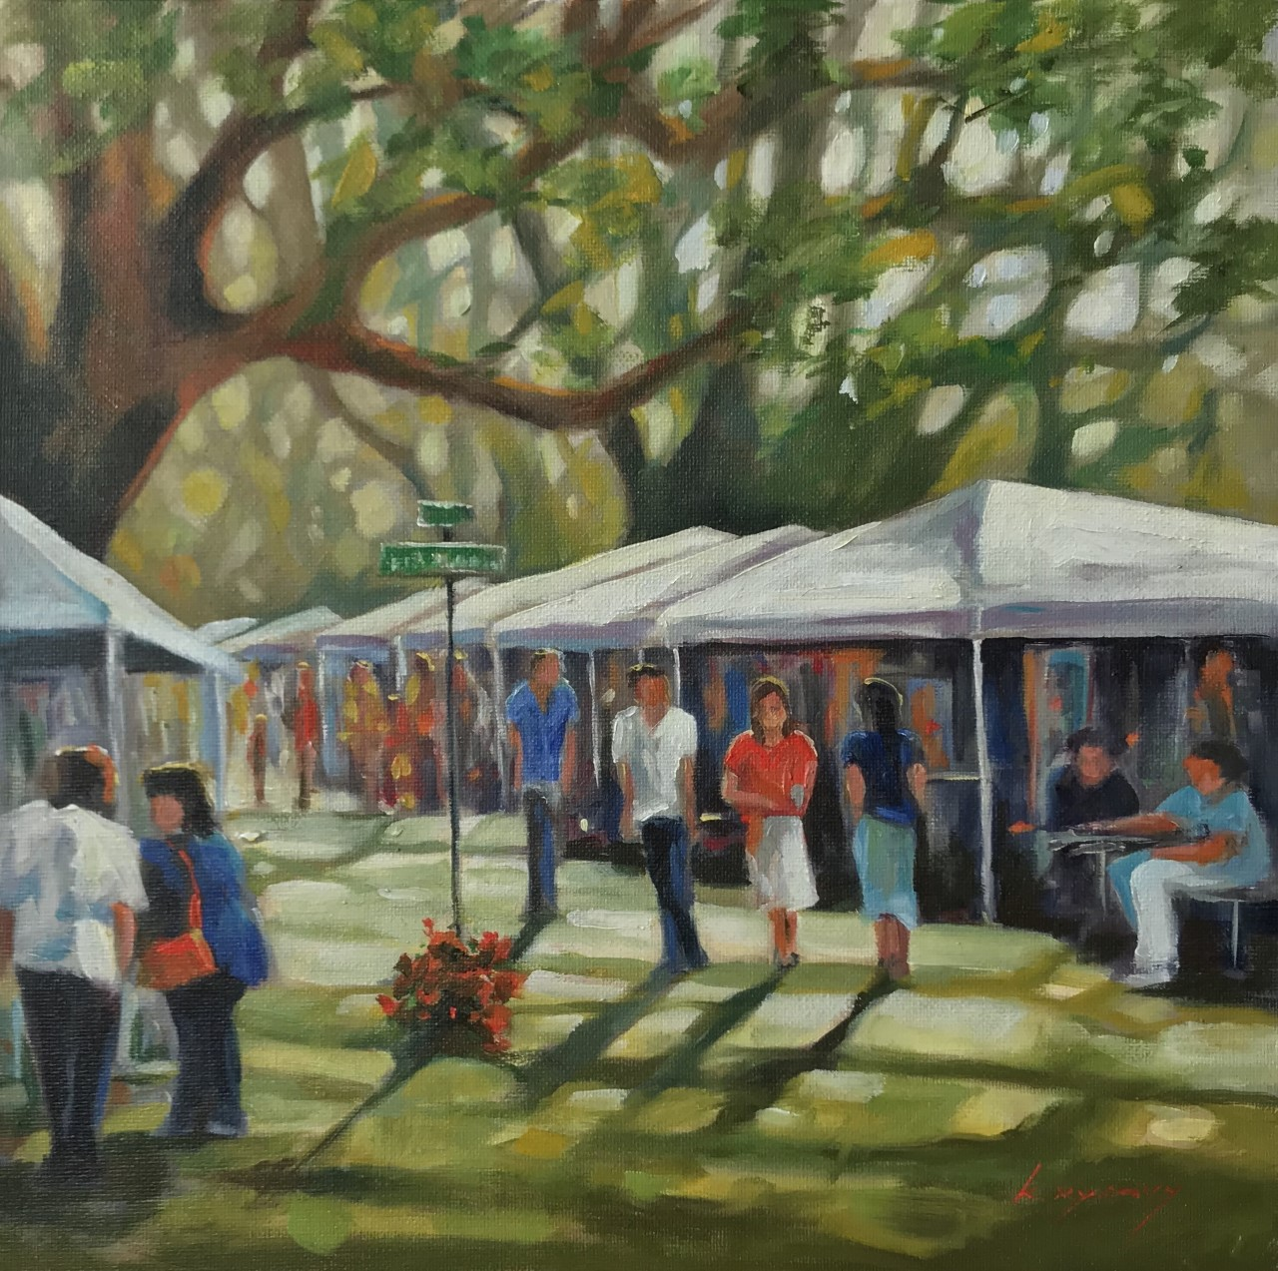
2020 Cover Artist Kelly Rysavy and her cover art “Under the Oaks”

Guests at the soiree will enjoy food and drinks catered by Lagran Saunders and Ben Baldwin and Last Call Bar Tenders as well as live musical entertainment.

The 20th Annual Chain of Parks Art Festival will be held on Saturday and Sunday, April
18-19, 2020, at the Bloxham, Lewis and Randolph “Chain of Parks,” located in Downtown Tallahassee. The festival is produced by LeMoyne Arts and Presented by Mad Dog Construction. For more information about the Chain of Parks Art Festival, visit www.chainofparks.com or email chainofparks@lemoyne.org.
###

