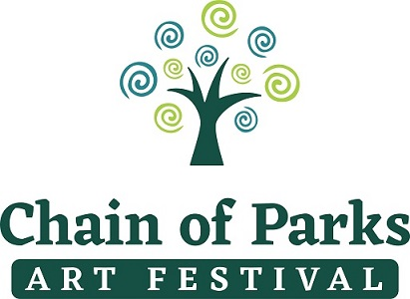

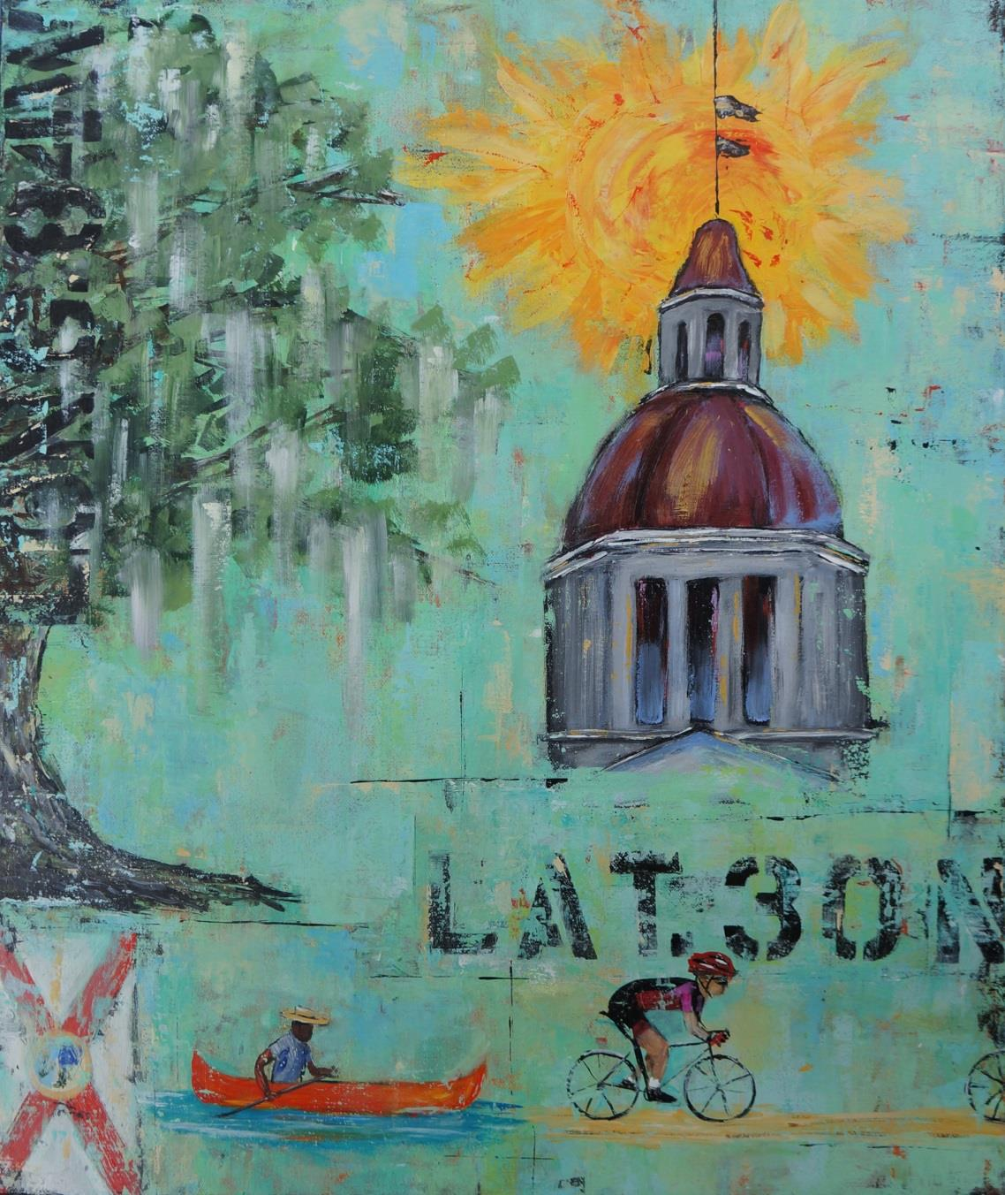
“Capital Life” by Lisa Rogers
2018 Chain of Parks Art Festival
Media Kit
Produced by Presented by
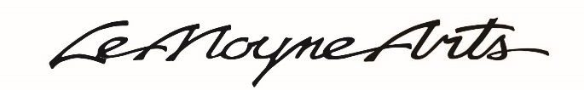

Press Release

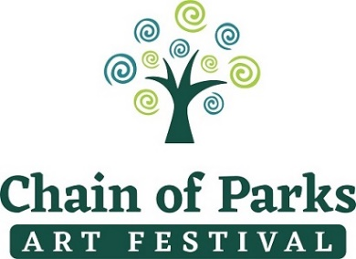
Produced by LeMoyne Arts
Presented by Mad Dog Construction

FOR IMMEDIATE RELEASE: Media Contacts: Kelly Dozier
Monday, April 16, 2018 (850) 544-6399
kelly@morethanbuildings.com
or
Taylore Maxey
taylore_m@yahoo.com
or
Vanessa Rowse
Chainofparks@lemoyne.org

Chain of Parks Art Festival

~Ranked #1 fine art festival in the nation! ~

TALLAHASSEE – Spring has sprung and the 18th Annual Chain of Parks Art Festival will be in full bloom this year, held on Saturday and Sunday, April 21-22, 2018, at the Bloxham, Lewis and Randolph “Chain of Parks,” located in Downtown Tallahassee. The festival will be open from 10:00 a.m. to 5:00 p.m., with an evening concert on Saturday night from 5:00 – 7:00 p.m. This is the perfect way to enjoy the City’s spring weather and indulge in the experience of a premier fine art festival!

The parks are located along Park Avenue, east of North Monroe Street. Visitors can view and purchase unique works of art from 170 juried fine artists, while enjoying a weekend that features local heritage re-enactments, artistic creations, mouth-watering culinary creations, fanciful children’s art activities and delightful live entertainment. It will be a family-friendly fun time for all.

Nationally ranked as the country’s #1 fine arts festival by Sunshine Artist Magazine™ (August 2017), this year’s event will not disappoint, with plans underway to ensure that title continues to be well deserved. Those who attend the festival will be able to view amazing, original, one-of-a-kind works of fine art while strolling under century-old trees in a charming Southern outdoor setting. Admission to the Chain of Parks Art Festival is free and open to the public.

“I am so very proud of the status that the Festival has attained, now officially being the #1 ranked fine art event in the country,” said Festival Chair, Kelly Dozier. “Every year, we get better and better, due in no small part to the work of many volunteers, staff and the very talented artists who participate. The impact to the City of Tallahassee is tremendous.”
A recent economic impact study shows that the 2017 festival resulted in approximately $1.4 million of direct spending in the Tallahassee community.

-MORE-

Chain of Parks Press Release
Page 2

The 2018 cover artist is painter Lisa Rogers. A Florida native and mother of two sons, Rogers says she has always had a love for the arts and developed a desire to turn “nothing into something” with any materials available. After a career in the legal field for many years, Rogers decided to pursue her artistic passion. She went back to school to learn various techniques, in addition to teaching herself a number of different crafts. Rogers found that painting revealed her true expression; her paintings reflect her Florida roots, and she specializes in landscapes, seascapes, animals and abstracts.

Her cover art, “Capital Life,” was exclusively commissioned for the festival and will be on display and for sale during the event. For additional information on the cover artist, please visit her website.

Through a continuing partnership with Sustainable Tallahassee, the festival is proud to “Go Green” for the third year. Our focus is to reduce landfill waste and food waste and to educate the public about recycling and other sustainable practices.

On Saturday, judges will review the artists’ works in each media category and awards (totaling $10,000) will be announced on Sunday morning. Winning artists will display their award ribbons and flags in their booths at the festival on Sunday.

On Saturday evening, the all-female swamp folk group The Krickets will perform this year. Hailing from Florida’s Gulf Coast, the band released its first album in May 2016 under producer Ben Tanner from the Grammy award-winning group Alabama Shakes. Soul bonding and folk driven, The Krickets have won multiple awards, including 2016 International Music and Entertainment Association (IMEA) Folk Artist of the Year Award.

Proceeds from the festival benefit the LeMoyne Center for the Visual Arts’ educational and exhibition programs.

For more information on the 2018 Chain of Parks Art Festival, please visit the website www.ChainofParks.com.

Be sure to “Like” us on Facebook, and “Follow” us on Instagram and Twitter @ChainofParks.

# # #

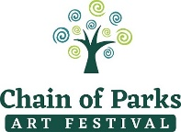

Story of Chain of Parks Art Festival
Third Weekend in April | April 21 and 22, 2018

Originally started in 2001, the Chain of Parks Art Festival was designed to offer our community an outdoor, fine art experience that was previously not found in the North Florida region. Prior to the establishment of the Festival, interested art enthusiasts would have to travel to South and Central Florida, or even farther to partake of festivals of this magnitude.

LeMoyne’s Executive Director at the time, Mary Beth Foss, began the festival by working with a few local artists who were interested in having an opportunity to participate in an outdoor fine art festival in this region. The Festival took its name from the beautiful venue in which it was first held, the Downtown Tallahassee “Chain of Parks” along Park Avenue—where it continues to be held to this day—and started as a small festival of approximately 50 local and regional artists.

The Festival was not only designed to be a diverse fine art experience, but also to provide a vehicle by which the LeMoyne Arts could raise funds for its ongoing art exhibitions and art education programs. During the life of the Festival, it has grown into LeMoyne’s primary fundraiser; in 2012, the Festival experienced a 50 percent increase in funds raised over the prior year, resulting in $65,000 of financial support for LeMoyne’s ongoing programs. The fundraising goal of the festival is to raise $100,000 annually for LeMoyne.

After eight years of being planned and organized by LeMoyne staff with assistance from volunteers, the Festival was transitioned into a volunteer-driven event. Volunteer Chairs were appointed by the LeMoyne Board, and Charles and Cynthia Tunnicliff and Kelly Dozier began to take the Festival to new heights. They were able to bring more artists into the Festival and broaden its reach through enhanced marketing and personal outreach to travelling artists. The result has been a Festival that is ranked as the #1 fine art festival in the country by Sunshine Artist Magazine™.

In 2009, Sheri O. Sanderson joined the Festival Committee as the Event Manager and brought her exceptional event management skills and experience to the team. Sheri managed all the intricate behind the scenes dealings with the artists, the Tallahassee Police Department, City of Tallahassee Parks and Recreation Department, Alcohol and Beverage Licensing, equipment rentals, the Festival Program and other printed materials and much more.

Kelly S. Dozier has served as Festival Chair since 2009. Through visiting other art festivals and having a keen eye to new ideas, she has brought a number of new initiatives to the Festival. Because of her efforts, more interactive opportunities, as well as depth to the experience, have been added to the Festival. Some of those initiatives include: The Village—including Community Partners and Children’s Art Programs; Jacques LeMoyne Living History Encampment; the “Greening” of the Festival; the “Be the Art” photo opportunities; and Pop-up Entertainment. Dozier also has served as Sponsor Chair since 2008, bringing in more than $65,000 in sponsorships each year.

Due to the phenomenal growth and increased complexity of producing the festival and the retirement of Sheri O. Sanderson, in 2017 a full-time Festival Director was brought in to manage the festival planning. Vanessa Rowse will debut as Festival Director in 2018, bringing her wealth of event planning and marketing experience to the team.

The festival continues to grow in quality and notoriety, and there is no sign that it will be slowing down any time soon!

The Festival Mission:
The LeMoyne Chain of Parks Art Festival was established to present an outdoor festival of high-quality original artwork and entertainment for the enjoyment of our Tallahassee area residents and visitors, while fostering the careers and financial support of local and regional artists, and raising needed funds for the operation of LeMoyne Center for the Visual Arts.

2018 Chain of Parks Art Festival Cover Artist
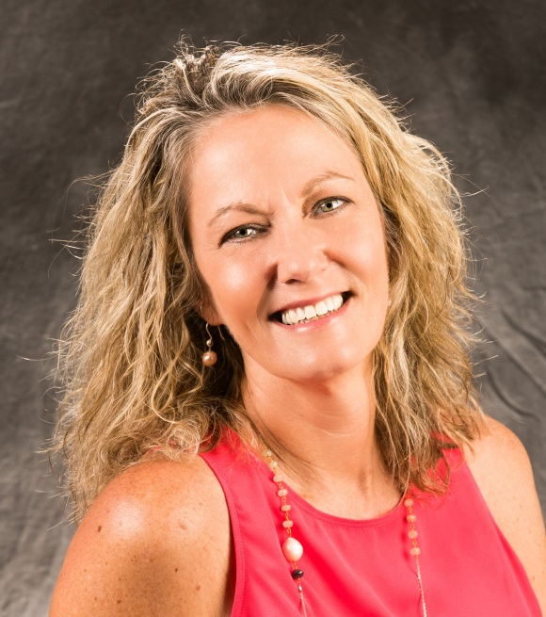
Lisa Rogers
The 2018 cover artist is painter Lisa Rogers. A Florida native and mother of two sons, Rogers says she has always had a love for the arts and developed a desire to turn “nothing into something” with any materials available. After a career in the legal field for many years, Rogers decided to pursue her artistic passion. She went back to school to learn various techniques, in addition to her self-teaching a number of different crafts. Rogers found that painting revealed her true expression; her paintings reflect her Florida roots, and she specializes in landscapes, seascapes, animals and abstracts.

Her cover art, “Capital Life,” was exclusively commissioned for the festival and will be on display and for sale during the event. For additional information on the cover artist, please visit her website.

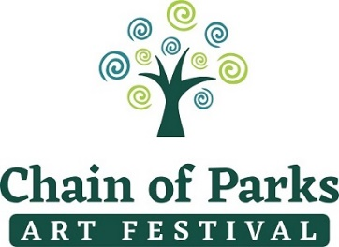

Chain of Parks Art Festival | April 21-22, 2018

Editorial Ideas

Media Contacts:
- Kelly Dozier | (850) 544-6399 | kelly@morethanbuildings.com
- Taylore Maxey | taylore_m@yahoo.com

LeMoyne’s 18th Annual Chain of Parks Art Festival and Cover Artist Lisa Rogers
LeMoyne Arts has hosted the Chain of Parks Art Festival for the past 17 years. This art festival brings together more than 170 fine artists from around the country to Tallahassee and offers attendees the opportunity to purchase amazing one-of-a-kind fine art creations. Known as one of the city’s most anticipated events during springtime, the Chain of Parks Art Festival brings a rich infusion of culture to the community. In addition, attendees can meet the festival’s 2018 cover artist, Lisa Rogers. Her work, “Capital Life,” will grace the cover of the festival magazine and will be on a variety of festival souvenirs offered for purchase. Find out more about the exciting experiences planned by visiting the website http://www.chainofparks.com.

The Economic Impact Study Prepared on the Chain of Parks Art Festival
The Chain of Parks Art Festival is nationally ranked in the Top 100 fine art and design festivals among thousands hosted every year across the country. This is due to the high-quality event and amazing sales of art during the festival. The Chain of Parks Art Festival has a significant positive impact on the local economy by bringing an influx of art lovers to Tallahassee where they spend, shop for art, food, lodging and much more!

A recent economic impact study shows that the 2017 festival brought $1.4 million in direct spending into the local community.

Chain of Parks Art Festival Partners with Sustainable Tallahassee to “Go Green in 2018!”
The festival is continuing our “go green” partnership with Sustainable Tallahassee focusing on reducing landfill and food waste while educating the public about recycling and other sustainable practices.

For more information about the Chain of Parks Art Festival, visit www.chainofparks.com or email chainofparks@lemoyne.org.

You can also “Like” us on Facebook and follow us on Instagram and Twitter @ChainofParks.

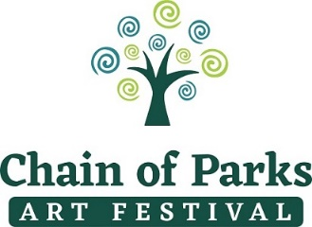

MEDIA ADVISORY FOR: Media Contacts: Kelly Dozier
Friday, April 20, 2018 (850) 544-6399 or
kelly@morethanbuildings.com

Taylore Maxey
(850) 212-5034
taylore_m@yahoo.com

Vanessa Rowse
Chainofparks@lemoyne.org

18th Annual Chain of Parks Art Festival
Ranked #1 Fine Art Festival in the nation!

TALLAHASSEE – The 18th Annual LeMoyne Chain of Parks Art Festival will be held on Saturday and Sunday, April 21-22, 2018. Visitors can view and purchase unique fine art creations from more than 170 artists from throughout the United States, while enjoying a weekend that features local heritage re-enactments, artistic creations, mouth-watering culinary creations, fanciful children’s art activities and delightful live entertainment.

WHO: LeMoyne Arts

WHAT: 18th Annual Chain of Parks Art Festival

WHEN: Saturday and Sunday, April 21-22, 2018
10:00 a.m. to 5:00 p.m.

Saturday, April 21, 2018
5:00 – 7:00 p.m.
Evening Concert, featuring The Krickets

WHERE: Downtown Chain of Parks,
located along Park Avenue, east of Monroe Street

PRICE: FREE

For more information on the Chain of Parks Art Festival events, including photos from past festivals, please visit the website at www.chainofparks.com.

Be sure to “Like” us on Facebook and follow us on Instagram and Twitter @ChainofParks.

# # #

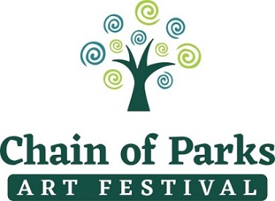

Chain of Parks Art Festival | April 21 – 22, 2018

Media Files

Cover Artist—Lisa Rogers

Cover Art —“Capital Life”

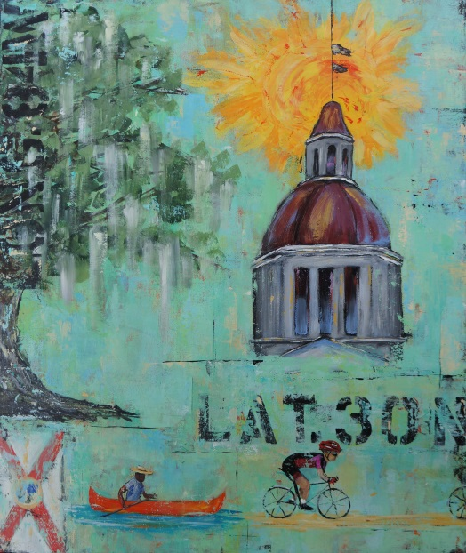
Chain of Parks Logo

