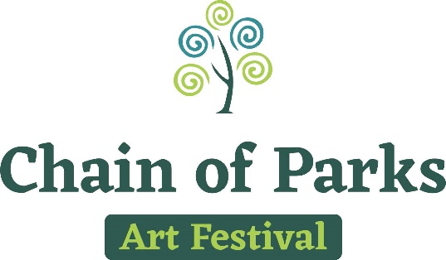

Produced by LeMoyne Center for the Visual Arts
Presented by Mad Dog Construction

PRESS RELEASE FOR: MEDIA CONTACTS:

Thursday, August 10, 2017 Taylore Maxey

taylore_m@yahoo.com

LeMoyne Chain of Parks Art Festival Ranked #1
Fine Art Festival in the Country
~ North Florida’s premier fine arts festival makes history with this accomplishment! ~

TALLAHASSEE – At a press conference held today, LeMoyne Center for the Visual Arts announced that the annual Chain of Parks Art Festival is ranked #1 as determined by Sunshine Artist™ magazine in their September issue. The 17th annual festival—presented by Mad Dog Construction—was held in April this year. Each year, in September, the magazine names the “100 Best Fine Art & Design Shows” in the country. Sunshine Artist™ is the leading publication for art and craft show exhibitors, promoters and patrons in the United States.
“We have always worked to make the Chain of Parks Art Festival a top-notch fine art event, attracting very talented and storied artists from throughout the country,” said Kelly S. Dozier, who has been the festival chair since 2009. “We were thrilled to be listed as one of the top 100 in the nation the last two years, but are astonished at the meteoric rise to #1 in 2017! This announcement confirms the quality of the festival and the community support that has led to this first-place ranking by Sunshine Artist™. As the magazine article said, Chain of Parks was a ‘speedy dark horse,” she continued, “but, we have come into the light and will work hard to maintain our distinguished place in the national art community.”
“Prior to Chain of Parks Art Festival, art enthusiasts in our region traveled to Central or South Florida to participate in events of this quality,” Vanessa Rowse, Festival Director, said. “This honor is especially nice because the festival is a volunteer-driven event and all the hard and dedicated work is now nationally recognized.”
The festival, designed to offer attendees an outdoor, fine art experience, aims to entertain and enrich all who attend. The Chain of Parks Art Festival is held during the third weekend in April each year at the Bloxham, Lewis and Randolph “Chain of Parks,” located along Park Avenue in Downtown Tallahassee. During the weekend, 35,000-40,000 people visit the festival, experiencing amazing, one-of-a-kind works of fine art by 170 artists from across the nation. Proceeds from the festival benefit the LeMoyne Center for the Visual Arts’ educational and exhibition programs.
The festival offers many unique experiences such as the opportunity to meet actors interpreting Jacques Le Moyne, the name sake of LeMoyne Arts Center and the first European to paint images of Florida and learn about 17th century Florida. Visitors love the large posters of art masterpieces into which they can poke their faces and take a picture as well as the diverse live musical entertainment. An initiative to eliminate landfill waste from the festival by recycling and eliminating Styrofoam and single use containers educated visitors about recycling and sustainability. Festival lane markers help visitors navigate through the parks while honoring local artists who have had a major impact at LeMoyne Art Foundation.
During the past two years, the LeMoyne Chain of Parks Art Festival was listed in the top 100 fine art festivals, placing 94th in 2016 and 87th in 2015. With this year’s ranking, the festival has achieved its highest ranking ever, forever placing it in the history books as a landmark achievement for events held in the City of Tallahassee and Leon County.
Each year, Sunshine Artist™ receives ballots completed by artists who participate in festivals throughout the country. Artists can submit up to 10 shows where they grossed the most revenue in sales of their works, with points awarded according to an artist’s total amount earned. For total sales of less than $2,000, the show gets one point; $2,000-$5,000, two points; $5,000-$10,000, three points; and for total artist’s sales of more than $10,000, the show receives four points. The magazine staff then tallies each show’s total points from all submitted ballots; the show with the most points earns the highest ranking. Ranking continues in descending order to achieve the top 100 Fine Art and Design shows (FA) and top 100 Classic/Contemporary Crafts shows.
The 2018 Chain of Parks Art Festival dates are Saturday and Sunday, April 21 and 22, 2018. For more information, please visit the festival website at www.ChainofParks.com. Be sure to “Like” the festival on Facebook™, and “Follow” us on Instagram™ and Twitter™ @ChainofParks.

###

