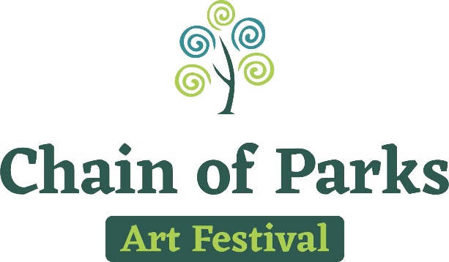

Produced by LeMoyne Center for the Visual Arts
Presented by Mad Dog Construction

FOR IMMEDIATE RELEASE: Media Contacts: Taylore Maxey
Thursday, January 11, 2018 taylore_m@yahoo.com

LeMoyne to Unveil 2018 Chain of Parks Art Festival
Cover Art and Artist at Soiree
~Donor Appreciation and 2018 Reveal Soiree~

TALLAHASSEE, Fla. – The LeMoyne Chain of Parks Art Festival will host a Donor Appreciation and 2018 Reveal Soiree, Jan. 18, thanking its loyal Festival supporters as it prepares for the April weekend, and also highlighting this year’s cover art and artist. The reveal is one of the most anticipated aspects of the Festival, held annually in Tallahassee.

The evening of art and music is set to take place Thursday, Jan. 18, 5:30 to 7:00 p.m., at the LeMoyne Center for the Visual Arts, 125 N. Gadsden St. Festival organizers will introduce inspiring cover art by Lisa Rogers, titled “Capital Life.”

“We are very excited to reveal the 2018 cover art piece especially designed to showcase Tallahassee and the Chain of Parks Art Festival,” said Kelly Dozier, Festival and Sponsor Chair. “We have other exciting news to share as we thank our Festival supporters and community for helping the Festival be recognized as the #1 Fine Art Festival in the nation.”

That other exciting news includes LeMoyne’s new Festival logo and website. The unveiling itself is set to take place at 6 p.m., and is open to the press.

Cover artist Lisa Rogers is a Florida native and mother of two sons. She says she has always had a love for the arts and developed a desire to turn “nothing into something” with any materials available. After practicing as an attorney for a number of years, Lisa decided to pursue her artistic passion, going back to school along with teaching herself a number of different crafts. Lisa says she found painting revealed her true expression -- her paintings reflect her Florida roots, and she specializes in landscapes, seascapes, animals and abstracts.

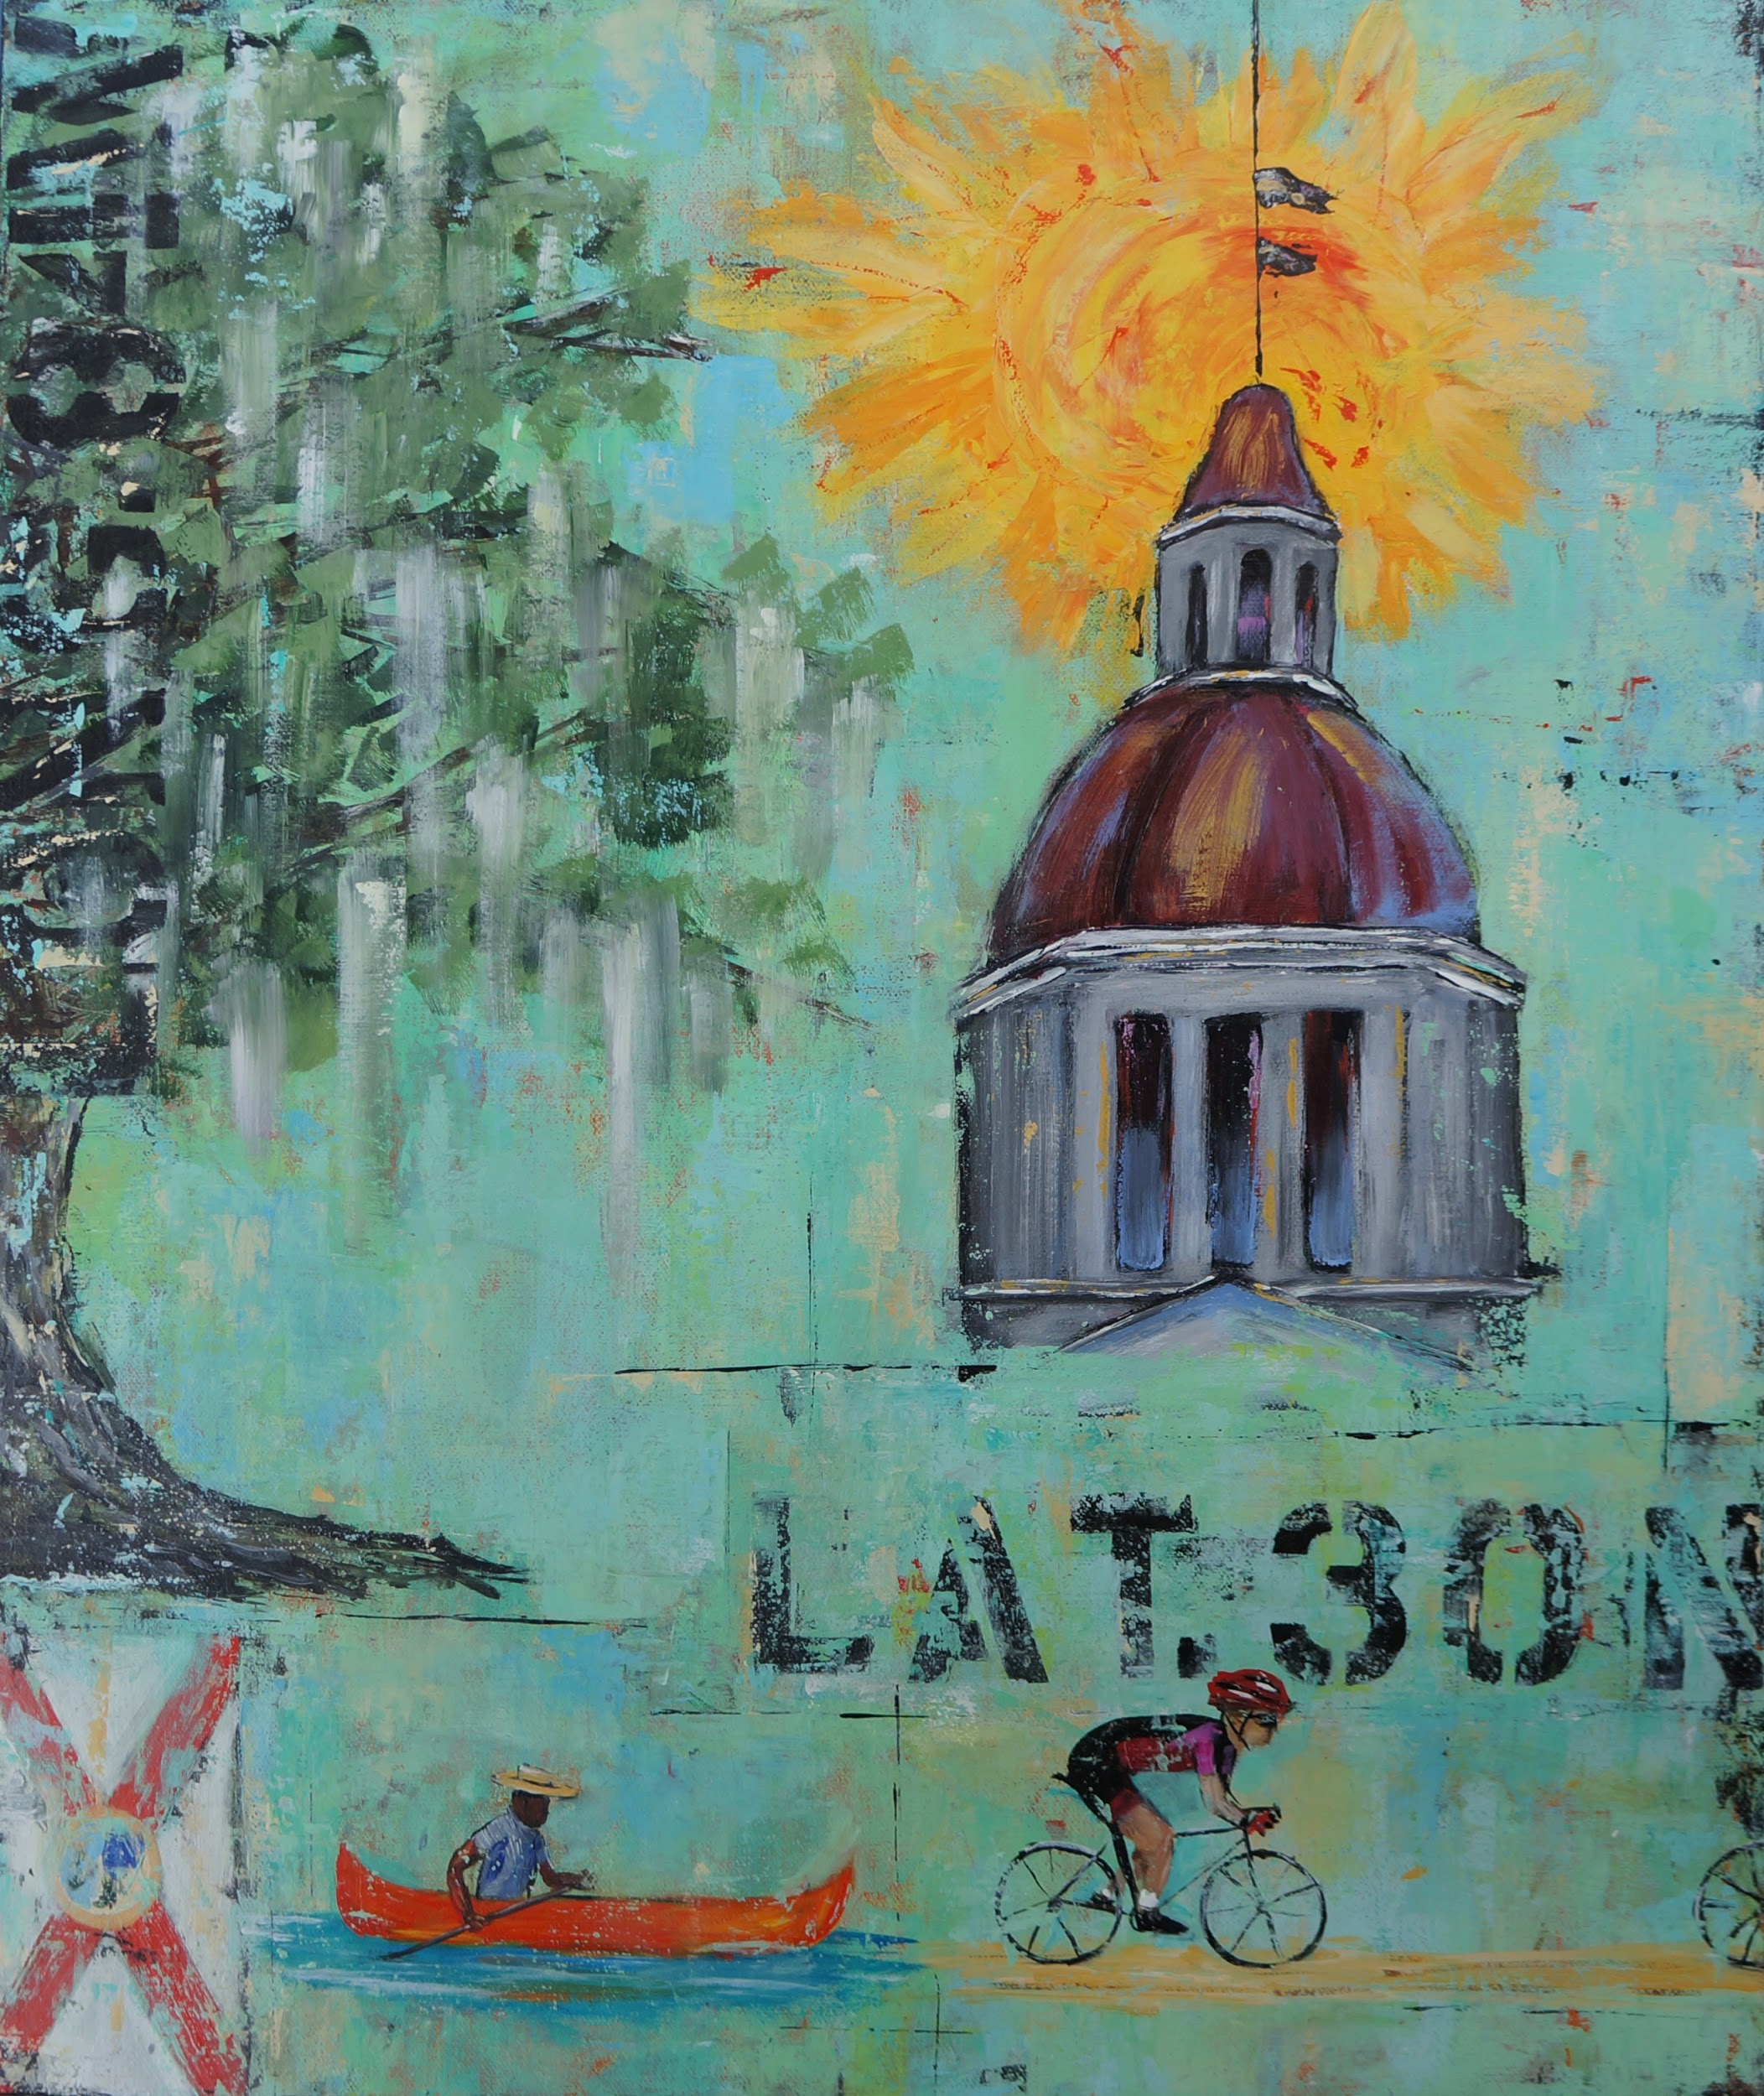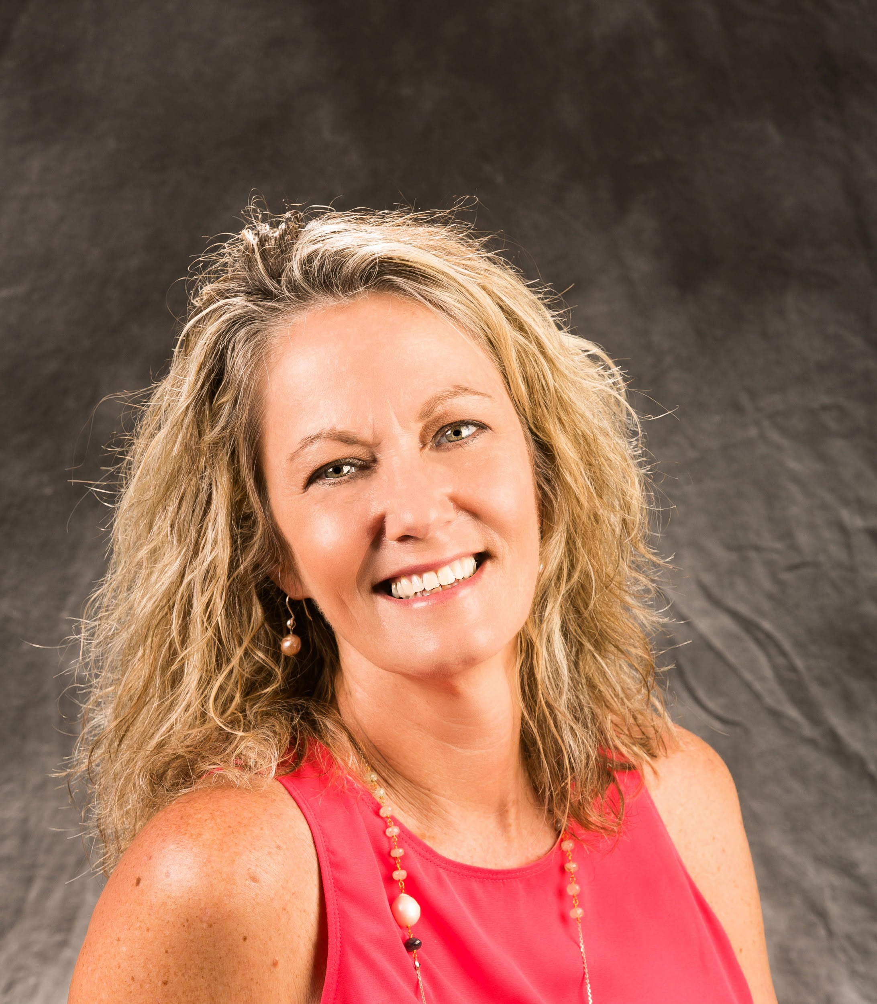
“Capital Life” and 2018 Cover Artist Lisa Rogers

Guests at the soiree will enjoy food and drinks catered by Lagran Saunders and Ben Baldwin, and will see a teaser video from The Krickets, a female swamp folk group from Florida's Gulf Coast, scheduled to be this year’s Saturday evening performance at the Festival. The band released its first album in May 2016 under producer Ben Tanner from Alabama Shakes. Soul bonding and folk driven, The Krickets have won multiple awards including 2016 IMEA Folk Artist of the Year Award.

The 18th Annual LeMoyne Chain of Parks Art Festival will be held on Saturday and Sunday, April 21-22, 2018, at the Bloxham, Lewis and Randolph “Chain of Parks,” located in Downtown Tallahassee. For more information about the LeMoyne Chain of Parks Art Festival, visit www.chainofparks.com or email chainofparks@lemoyne.org.

###

